Lucas Brown
MUSC 752- Advanced Rehearsal Techniques and Pedagogy

Handbook Section 1
Method Books and Repertoire

Method Books
- Piano Adventures- Nancy and Randall Faber- Primer Level through Level 5
- Bastien’s Piano Library- James Bastien- Primer Level through Level 4
- Alfred’s Piano Course- Willard Palmer, Morton Manus, Amanda Vick Lethco- Level 1A through Level 6
- Premier Piano Course- Martha Mier- Primer Level through Level 6

Literature (By Method Series)
- Popular Repertoire- Nancy and Randall Faber- Primer Level Through Level 5 (FJH)
- Christmas Songs- Nancy and Randall Faber- Primer Level through Level 5 (FJH)
- Popular Hymns- James Bastien- Primer Level Through Level 4 (Neil A. Kjos)
- Popular Christmas- James Bastien- Primer Level Through Level 4 (Neil A. Kjos)
- Boogie, Rock and Country- James Bastien- Primer Level Through Level 4 (Neil A. Kjos)
- Praise Hits- Willard Palmer, Morton Manus, Amanda Vick Lethco- Level 1A-Level 6 (Alfred)
- Popular Hits- Willard Palmer, Morton Manus, Amanda Vick Lethco- Level 1A- Level 6 (Alfred)
- Hymn Book- Willard Palmer, Morton Manus, Amanda Vick Lethco- Level 1A- Level 6 (Alfred)
- Christmas Book- Willard Palmer, Morton Manus, Amanda Vick Lethco- Level 1A-Level 6 (Alfred)
- Fun Book- Willard Palmer, Morton Manus, Amanda Vick Lethco- Level 1A-Level 6 (Alfred)
- Top Hits- Willard Palmer, Morton Manus, Amanda Vick Lethco- Level 1A- Level 6 (Alfred)

Etudes/Studies
- J. S. Bach- Well Tempered Clavier- J. S. Bach/Ed. Carl Czerny (Schirmer)
- F. Chopin- Etudes- F. Chopin/Ed. Freidheim (Schirmer)
- C. Czerny- 30 New Studies in Techniques Op. 849- Czerny/Palmer (Alfred)
- C. Czerny- 40 Daily Exercises Op. 337- Czerny/Hinson (Alfred)
- C. Czerny- 24 Easy Studies for the Left Hand Op. 718- Czerny/Hinson (Alfred)
- C. Czerny- Selected Piano Studies Volume 1- Czerny/Ed. Germer and Palmer (Alfred)
- C. Czerny- School of Velocity Op. 299- Czerny/Ed. Palmer (Alfred)
- C. Czerny- Art of Finger Dexterity Op. 740- Czerny/Palmer (Alfred)
- C. L. Hanon- The Virtuoso Pianist- Charles-Louis Hanon (Alfred)

Solo Repertoire- Beginner to Advanced

EASY
- Piano Literature Vol. 1- Ed. James Bastien (Neil A. Kjos)
- Piano Literature Vol. 2- Ed. James Bastien (Neil A. Kjos)

INTERMEDIATE
- Winter Rhapsody- Dennis Alexander (Alfred)
- The Great Northwest- Dennis Alexander (FJH)
- Sinfonias and Inventions- J. S. Bach (Alfred)
- Piano Literature Vol. 3- Ed. James Bastien (Neil A. Kjos)
- Five Character Pieces- Alfredo Barili/Ed. William Ransom(Neil A. Kjos)
- The Empire State- W. T. Skye Garcia (FJH)
- Michigan Images- Marilynn Ham (FJH)
- Call of the Medowlark- Kevin Olson (FJH)
- Meteor Showers- Kevin Olson (FJH)
- Midnight Sonatina Op. 70 no. 15- Myra Brooks-Turner (FJH)
- Autumn Leaves- J. Mercer, J. Prevert, J. Kosma (Hal Leonard)

ADVANCED
- With These Hands (7 Early Advanced Solos for Piano)- Dennis Alexander (FJH)
- Concerto- J. S. Bach (Schirmer)
- Eight Little Organ Fugues- J. S. Bach (Schrimer)
- Nine Sonatas- Wihelm Friedmann Bach (Kalmus)
- Piano Literature Vol. 4- Ed. James Bastien (Neil A. Kjos)
- Piano Literature Vol. 5- Ed. James Bastien (Neil A. Kjos)
- Piano Literature Vol. 6- Ed. James Bastien (Neil A. Kjos)
- Moonlight Sonata- Ludwig van Beethoven (Hal Leonard)
- Sonata Op. 79- Ludwig van Beethoven (Schirmer)
- Selected works for Piano- Claude Debussy/Ed. Keith Snell (Neil A. Kjos)
- Water Music- G. F. Handel (Hal Leonard)
- Sonata Album- Beethoven, Haydn, Mozart/Ed. Keith Snell (Neil A. Kjos)
- Piano Concerto In D- F. J. Haydn (Schirmer)
- Charmes- Federico Mompou (Editions Max Eschig)
- Piano Concerto No. 13- W. A. Mozart (Barenreiter)
- Piano Concerto No. 23- W. A. Mozart (Kalmus)
- Piano Sonata No. 1- Dianne Goolkasian Rahbee (FJH)
- Piano Sonata No. 3- Dianne Goolkasian Rahbee (FJH)
- Piano Concerto No. 2- D. Shostakovich (International Music Co)
- Piano Concerto No. 1 in b-flat minor- P. I. Tchaikovsky (Schirmer)

Note: The piano is such a versatile instrument there is a pleothra of literature for this instrument. I plan to continue to add to this through the course of this semester.

References
Son, J. W. P. and. (n.d.). Jwpepper.com. J.W. Pepper Sheet Music. Retrieved June 8, 2022, from https://www.jwpepper.com/sheet-music/welcome.jsp
J.W. Pepper is a great website for any instrument or vocal-focused group to find music. I specifically searched piano music. J.W. Pepper has a great feature where you can sort out what state you are in which allows it to show you what music is on your state’s festival lists. I use this many times when compiling my repertoire list.
Alaska Piano Competition Repertoire List (Intermediate) i6. University of Alaska Anchorage. (n.d.). Retrieved June 8, 2022, from https://www.uaa.alaska.edu/academics/college-of-arts-and-sciences/
This website lists the pieces that are in the intermediate category for the University of Alaska Anchorage Piano Competition. This list is sorted by music period and has many options to choose from. The selection is very eclectic and has pieces from all of the prominent composers of each period in chronological order.
Suggested repertoire - piano festival - ihsma.org. (n.d.). Retrieved June 8, 2022, from https://ihsma.org/wp-content/uploads/2017/02/piano_sug_rep.pdf
Iowa High School Activities Association has a piano festival where students can compete in a festival just as they would in band or choir. This website provides a full comprehensive list of literature that is allowed for performance for this festival. The list is leveled from one to six, with additional materials if necessary.

Lucas Brown
MUSC 752- Advanced Rehearsal Techniques and Pedagogy

Handbook Section 2
- Instrument pitch tendencies and solutions
- Teaching techniques and insights – tone production, fundamentals, common fingering alternates, etc.
- Include a recommended warm-up or fundamentals routine

How does my piano create a sound?
A piano is a complex system of strings and hammers that work together to produce a sound. When a key is pressed on the piano keyboard, a hammer inside the piano moves and strikes a string to create or produce a tone. When you use light weight on the key a softer sound is produced and when you apply more weight to the key a firmer, louder sound is produced.

Piano Basics- Getting Started at the Piano
To get started, you first need to establish the correct posture while sitting at the piano. It is essential when sitting at the piano, that you sit within an arm’s length of the finger board so that only the fingertips reach the finger board and then drop your arms to your side while sitting up tall. Legs should be positioned comfortably at a ninety-degree angle to the floor with the feet flat on the floor and the right foot should sit slightly in front of the left foot. This is because the right foot is used mainly for the damper pedal which is located to the right of the three pedals on the piano.

Hand Position
Your hand should maintain a natural curve while playing the piano. This will ensure that your fingers have a full range of motion while playing the piano. This will be the most comfortable position for your hands while sitting and playing piano. Each finger should have a natural and free range of motion.

Practice This- Finger Movement/Independence- Flexibility Warm-up
While sitting at the piano, hold your hands with your fingertips facing the ceiling. Practice wiggling each finger independently. (Keeping in mind the number for each correlating finger…... 1-Thumb, 2- Index Finger, 3- Middle Finger, 4- Ring Finger, 5- Pinky- See Diagram Below- Figure 1).
RH Finger 1 LH Finger 1
RH Finger 2 LH Finger 2
RH Finger 3 LH Finger 3
RH Finger 4 LH Finger 4
RH Finger 5 LH Finger 5

Figure 1- Finger Numbers- Piano
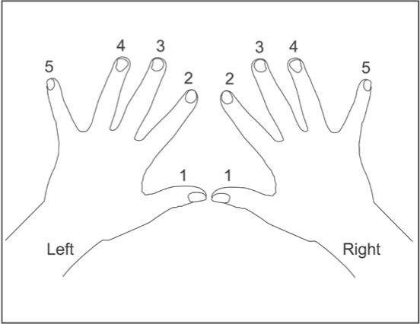
Finger numbers: Piano scales, piano, free piano lessons. Pinterest. (2012, February 2). Retrieved June 14, 2022, from https://www.pinterest.com/pin/finger-numbers--95983035778163243/
Practice This!
A good way to ensure that your hand position feels natural and correct, is to hold your hand with your palm facing the ceiling, then imagine holding a softball in your hand, creating a cup-like formation. When your hand has the cup-like shape then turn it over dropping the imaginary softball maintaining the cup-like shape and then placing our hands on the piano keyboard. This should have a comfortable and natural feeling, where not strain is felt.

How to sit at the Piano
When you first start to instruct student on the appropriate way to sit at the piano there are several things that will help them maintain a strong and poised posture while sitting at the piano.
- Sit Tall- Do Not Slouch
- Lean slightly forward- not as if you are napping on the keyboard, but far enough that you have leverage for balancing your body.
- Let your arms hang loosely at your sides, from your shoulders.
- Make sure that the bench in positioned square and in-line with the keyboards.
- Knees should be positioned slightly underneath the piano keyboard.
- Feet flat on the floor, right foot slightly forward, left foot slightly under the bench.

How do I tune my piano?
The easiest way to tune a piano is to have it professionally tunes, so that strings inside the piano are not stretched, damaged, or broken. The piano should be tuned ideally every six months to a year. This is to ensure that they instrument does not have slippage or swelling in the tuning pegs and so that your strings maintain accurate pitch.
A pianos tuning will fluctuate depending on the climate in which it is stored and played in. It is best to keep your piano in a room where the climate is a steady temperature year-round.

Teaching Piano……. In the Beginning…...
When teaching piano, it is imperative that correct hand position, fingering, and technique is stressed. This will help alleviate the creation of poor habits and technique as your students’ progress. An example of the importance of reinforcing the correct technique is at the beginning of the technique book in the Technique and Artistry Book in the Piano Adventures Series published by FJH music, each level has numerous technique activities that are stressed and reinforced through the entire course. These exercises are as follows: round hand position (reinforcing the round hand position needed to play the piano), relaxed wrist (reinforcing the use of a relaxed controlled wrist, to help with reducing tension in the beginning piano student), light hand bounce (to help with playing light and bouncy, for learning and reinforcing the use of staccato playing), and finger independence (reinforcing the use of each finger independently).
When a student first comes to their lesson keep reminding them to check their posture. Sit up straight, position the body half on the bench and half off the bench, feet flat on the floor, and right foot slightly in front of the left. This will help alleviate any tension that may be caused by poor posture. Also, it will help their mobility later when they move into the more advanced musical pieces so that they are able to reach both the high and low portions of the keyboard.

Fingering…. Starting to play the Piano
When starting to play the piano, it is important that you stress the use of correct fingering for your students. If the student practices and created poor habits in the use of correct fingering they will have difficulty playing technically challenging pieces accurately and precisely.
This will cause a great amount of frustration and even loss of interest.

Fingering in Piano music is found directly in most editions of the repertoire purchased. These are identified as numbers that are positioned over the notes and phrases in the score. Each edition may vary in the way that they utilize the fingering system for each work. However, the fingering provided is used as a vehicle to successfully execute the passage with a piece or work. See figure 2.

Figure 2-Fingering Numbers in Piano Music
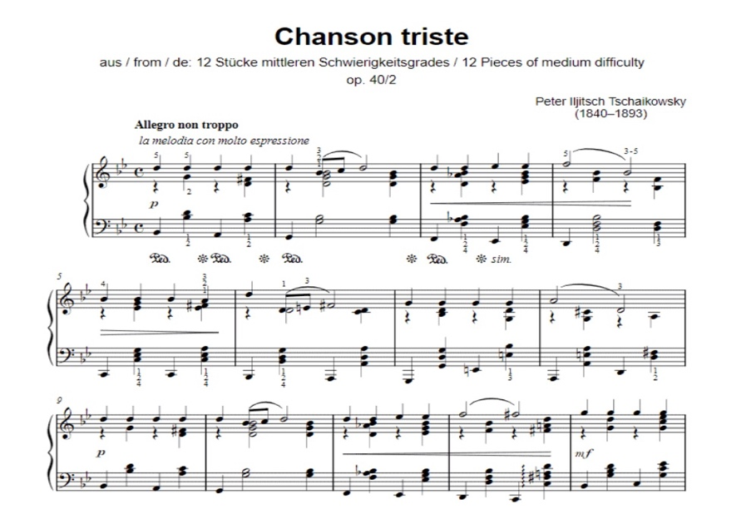
Do I really need to follow the fingerings in my piano music? Musicnotes Now. (2021, March 8). Retrieved June 14, 2022, from https://www.musicnotes.com/now/tips/do-i-really-need-to-follow-the-fingerings-in-my-piano-music/

Common Warm-Up Routines
There are many ways to warm-up at the piano, below are a few suggestions.

Wiggle Correlating Fingers (together on both hands)
Wiggle finger:
1
2
3
4
5

Stretching Your Fingers
Take your pointer finger and pull it back, carefully towards your wrist, repeating this exercise for each finger on each hand. Be careful not to over stretch, this could cause damage to the muscles in the hand or cause cramping. This warm-up is to help with the dexterity and flexibility of the fingers on each hand. This will also loosen up the muscles and allow the hand to move more freely alleviating any tension in the hand.

Flexibility and Dexterity Warm-Ups
Using exercises such as Czerny- Exercises in Flexibility and Dexterity, Hannon- the Virtuoso Pianist, J.S. Bach- Two- and Three-Part Inventions, and Well-Tempered Clavier are strong exercises to warm-up the hands for playing the piano.
Each of these exercises focus on strengthening the muscles in the pianist’s hands.

Breathing
There is a common misconception in the playing of the piano about breathing. However, when playing the piano if we practice breathing in a musical way, we are better able to focus on the expression of the music that we are playing.
Breathing is an everyday occurrence for us as humans, however, to breath musically is another technique entirely. Breathing musically helps with the structuring of the piece of music and its phrase structure. Commonly pianists forget to breath or breath in a very shallow manner when playing technically difficult pieces. The lack of strategically or planned breathing can cause more problems such as anxiety. (Better Breathing for Pianists: https://www.youtube.com/watch?v=5ghX9tPkxOQ)

To Start……
1. Sit up straight on the piano bench.
2. Let your arms hang loosely from your shoulders at your side.
3. Start taking deep relaxed breaths, breathing in for four beats, and out for four beats.
4. Be sure that your breaths cause your diaphragm (What is the diaphragm: https://www.youtube.com/watch?v=0PyDEna7qs0) to expand, not allowing your shoulders to raise. A solid breath is taken in through the nose and out through the mouth, allowing the lungs to fully expand, causing the diaphragm to contract allowing air into the lungs. When you exhale, your lungs contract causing the diaphragm to expand pushing the air out of the lungs.
5. Repeat this procedure, altering the number of beats for inhalation, and exhalation.
Alternate Inhalation/Exhalation Counts:
Beats In | Beats Out
4 | 6
4 | 8
4 | 12
6 | 8
6 | 10
6 | 12
8 | 4
8 | 6

This process can be repeated a number of ways that allow you to work on controlling your breathing while your play.

Next……
Play a simple four-part chorale while practicing controlled and focused breathing.
1. Play through the piece of music.
2. Breath after every fermata. (In this type of music, the fermatas establish each phrase, or where breaths are commonly placed).
3. When you are able to play through these with correct breathing, take and apply these techniques of breathing to more difficult pieces.

Examples of four-part chorales are listed in Figures 3-6 below.

Figure 3:
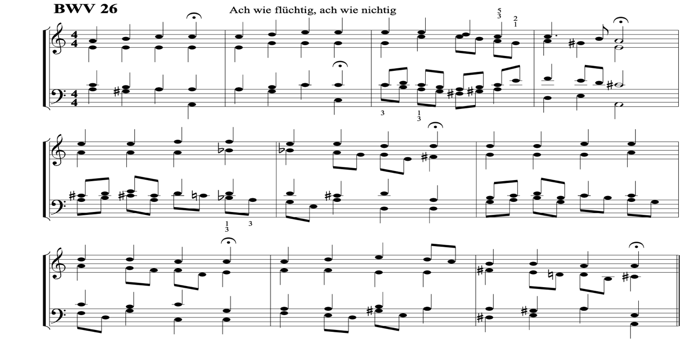

Figure 4:
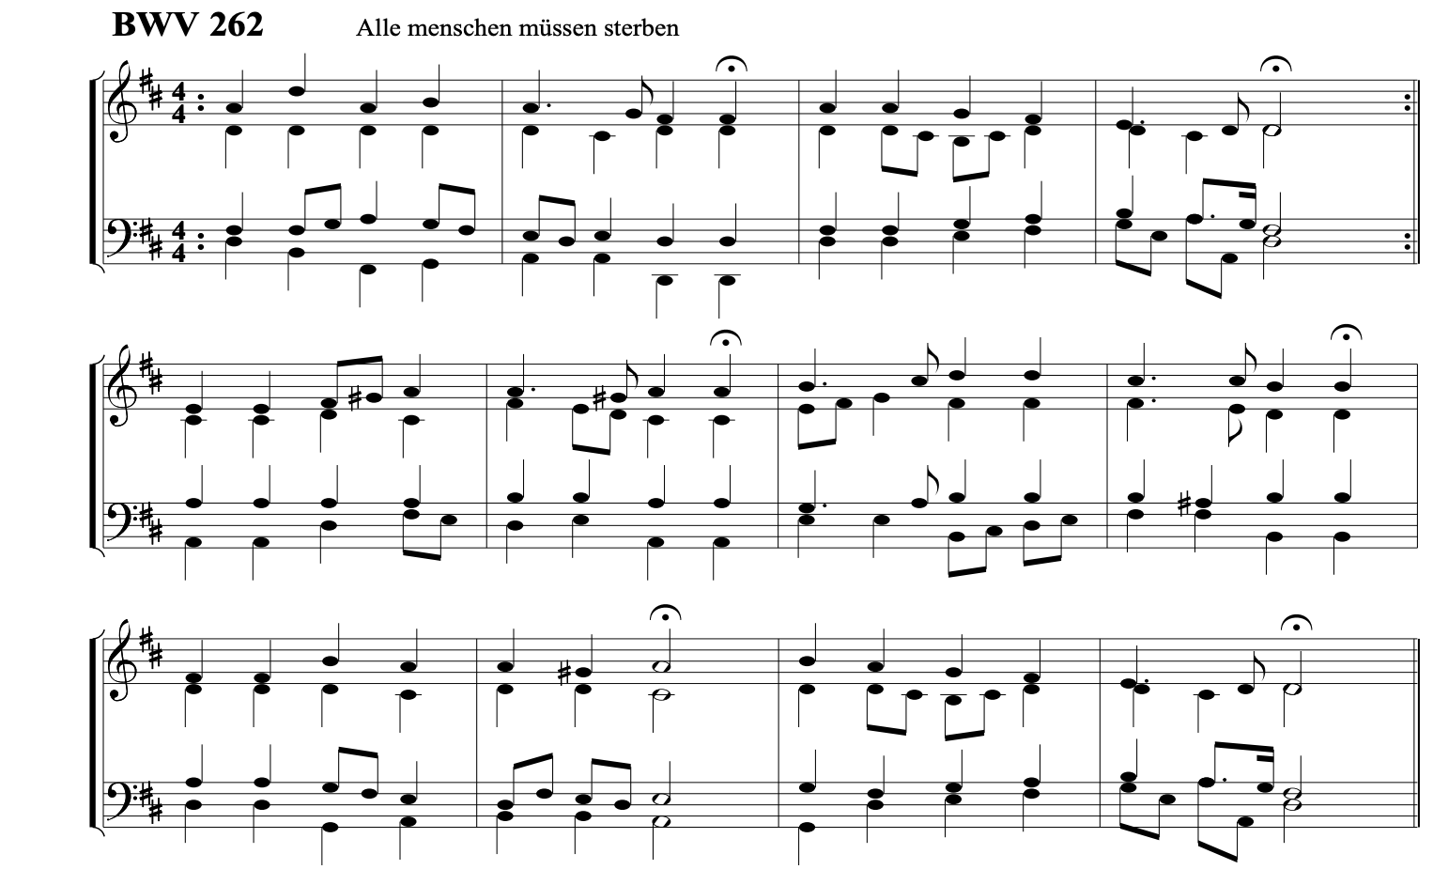

Figure 5:
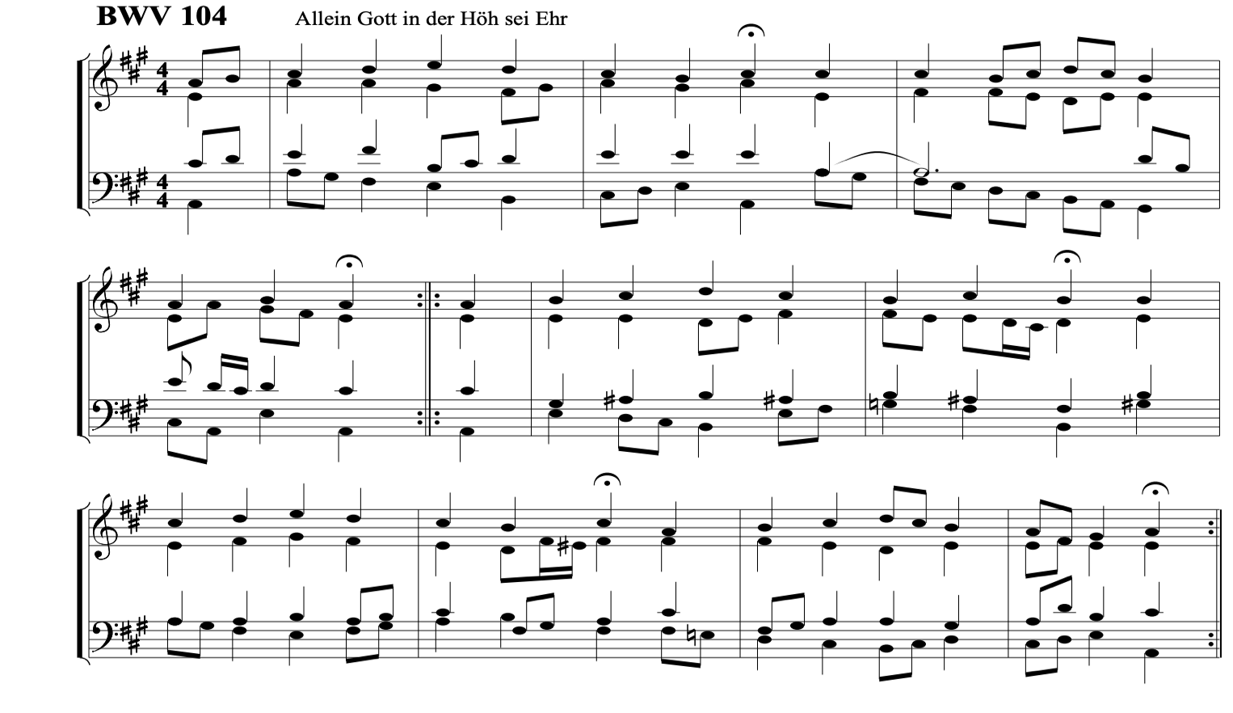
Figure 6:
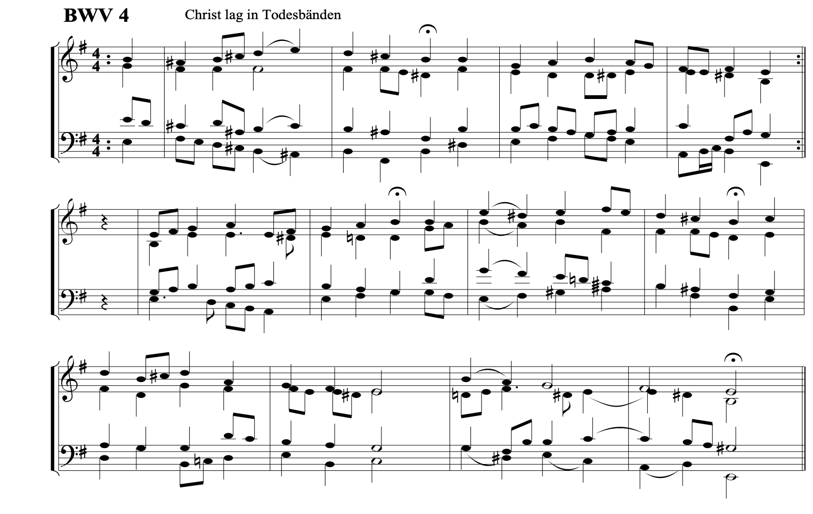
Forty Bach Chorales - pjb.com.au. (n.d.). Retrieved June 14, 2022, from https://pjb.com.au/mus/free/satb_chorales.pdf
Lucas Brown
MUSC 752- Advanced Rehearsal Techniques and Pedagogy

Handbook Section 3
• Recommended mouthpieces/bows/sticks/reeds, etc.:
beginning through professional if applicable
• Recommended instrument brands: beginning through professional.
• Professional organizations related to your instrument: International Trumpet Guild, American String Teachers Association, etc. (for example).
• List a few recommended professional performers • Recommended websites • Anything else you deem important

Professional Organizations for Piano Teachers
- New England Piano Teachers Association-
https://nepta.com/to-join/?gclid=Cj0KCQjwntCVBhDdARIsAMEwACmJYusKUO53d2OB9anPABEsNnXLoc-Wq-Rcr3kWzH6Aw5f-V1FG95caAhBrEALw_wcB

- Music Teacher’s National Association-
https://www.mtna.org/

- Saint Paul Piano Teacher’s Association-
https://sppta.org/membership

- American College of Musicians (USA)-
https://pianoguild.com/

- National Federation of Music Clubs-
https://www.nfmc-music.org/

Recommended Instruments/Brands for Pianists
Although there is not an extensive list of required instruments, or materials for a pianist except to have a playable medium to high quality piano/keyboard. Below is a list of preferable Pianos/Keyboards:
- Yamaha
- Korg
- Baldwin
- Kawai
- Williams Symphony Grand II (Digital Piano used by many professionals, myself included.)
- Roland
- Estonia (A very affordable foreign piano, made in Estonia- has a clear and precise tone.)
- Steinway

Recommended Pianists for Listening
- Peter Bence
- Jarrod Radnich
- Yiruma
- Lionel Yu
- Jon Schmidt- Piano Guys
- Jacob Collier
- Brad Mehldau
- Martha Argerich
- Mitsuko Uchida
- Andras Schiff
- Lang Lang
- Helene Grimaud

References
Milstein, H., G, M., Kelly, T. J., Gelman, B. M., Es, Kernen, W., Seve, V., Any, & Shayeva, E. (2021, January 8). 16 of todays greatest living classcial pianists~ the sound advocate. The Sound Advocate. Retrieved June 23, 2022, from https://www.thesoundadvocate.com/2018/10/16-of-todays-greatest-living-classical-pianists/
Nugent, J. (2021, November 5). The 12 best modern pianists you should know. Higher Hz. Retrieved June 23, 2022, from https://higherhz.com/best-modern-pianists/

Recommended Websites (Reference Format APA 7)

Fun and affordable sheet music, worksheets, and Lessons Kids Love and teachers trust. MakingMusicFun.net - Sheet Music, Lesson Plans & Composer Resources. (n.d.). Retrieved June 23, 2022, from https://makingmusicfun.net/
Piano Teachers connect. Piano Teachers Connect. (n.d.). Retrieved June 23, 2022, from https://pianoteachersconnect.com/
Piano Teaching Resources, teaching kids & teenagers piano | teach piano ... (n.d.). Retrieved June 23, 2022, from https://www.teachpianotoday.com/
Website builder for music teachers with templates. Bandzoogle. (n.d.). Retrieved June 23, 2022, from https://bandzoogle.com/websites-for/music-teachers?utm_source=google&utm_medium=cpc&utm_campaign=Search_Customer_Types&utm_content=Music_Teachers&utm_term=piano+teacher+website&device=c&kw_matchtype=e&network=g&gclid=Cj0KCQjwntCVBhDdARIsAMEwACnExvXSz42F0d5mIBmh1418cS5Bz99M027YGz7OHEtdrYP1oTsKpP0aAoX6EALw_wcB

