Lucas Brown
Score Study Worksheet- Week 2
PHASE III

Title: First Suite in E-Flat

Composer: Gustav Holst

- Composer Background:
Born: September 21, 1874- Cheltenham, Gloucestershire, England
Died: May 25, 1934- London, England

Major Instruments: Trombone, more of an organist (which explains how he can create a full rich sound in the musical works that he composes)

General Compositional Style: Incorporated styles of Maurice Ravel, and Igor Stravinsky, in the style of English Romanticism.

Holst’s Significant Works:
- The Planets
- First Suite in E-Flat
- Second Suite in F
- Egdon Heath
- Choral Fantasia
- Fugal Concerto for Flute, Oboe, and String Orchestra
- Saint Paul’s Suite

- Significant Information learned Printed in Score:
- No information was printed in the score.

- Duration of the Piece if Music:
- Movement 1- Chaconne- 4:50
- Movement 2- Intermezzo-2:53
- Movement 3- March- 2:58

Total Time: 11:00 minutes

- Date of the Piece of Music: Finished in 1909, was premiered in 1920
Phase III-
An interesting note that I have found in my research for his work is that Holst actually has meant for this work to be played, without pause between each movement. His reasoning for this was because all of the movement use the same melodic motive/theme. He has it drawn out in the original autographed manuscript.
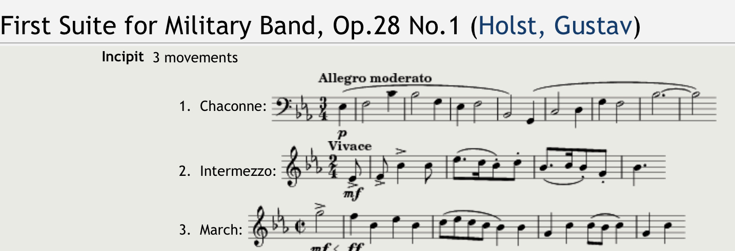
Holst, G. (n.d.). First Suite for Military Band, op.28 no.1 (Holst, gustav). IMSLP. Retrieved June 18, 2022, from https://imslp.org/wiki/First_Suite_for_Military_Band%2C_Op.28_No.1_(Holst%2C_Gustav)

- Tempi:
- Movement 1: Allegro Moderato
- Movement 2: Vivace
- Movement 3: Tempo dI Marcia

- Level of Difficulty: Advanced/ Grade 3.5-4 (4)

- Unusual Instrumentation: There are no unusual instruments in this piece.
Phase III-
- Instrumentation in this piece is typical of the scoring for band at this time, as this was a new instrumentation for large ensemble and it was just becoming popular, we find that there are instruments that are less common in the score than instruments of today.
- Instruments such as the Db Fl. and Picc, Eb Cl., Bb Bass Sax, Bb Ctra Bs Cl, both Crnt, and Trpt (where as we use just trpt in modern music), Fl Hrn, Eb Horn. These are all different than modern concert band scoring.
- Glossary of Terms:
- There is not a glossary of terms provided, most terms are either in Italian or English.
Phase III-
- Terms that are used in this score:
Legato, Staccato, Cresc, Tutti, Brilliante, Tenuto, Pesante, diminuendo, Crescendo a poco a poco, Maestoso, ritardando al fine, soli, solo, vivace, con sordino, L’istesso tempo, dolce, senza sordino, morendo, Tempo di Marcia, con largezza, Trio, meno mosso, piu mosso.
- Common Dynamics- ppp, pp, p, mp, mf, f, ff, fff.
- Common Articulations- accent, slur, phrase, legato, staccato, fermata.

- Measures Numbered in Score: No
Phase III-
As I continue my work on this piece I will transfer all the numbers for the measures into my scores, that I use, I usually just refer to the printed rehearsal numbers, but because there are very few in this piece, I plan to number my score.

- Recordings Studied: Northern Texas Wind Symphony (Found on iTunes Apple Music)

- Relevant Literature on the Work Studied:
Caldwell, J. (2010, July 6). Gustav Holst: "First suite in eb". umwo. Retrieved June 8, 2022, from https://www.umwindorchestra.com/single-post/2010/07/06/gustav-holst-first-suite-in-eb
First Suite. Wind Repertory Project. (n.d.). Retrieved June 8, 2022, from https://www.windrep.org/Articles:First_Suite
Holst First Suite in E-flat. Download limit exceeded. (n.d.). Retrieved June 8, 2022, from https://citeseerx.ist.psu.edu/viewdoc/download?doi=10.1.1.867.9680&rep=rep1&type=pdf
Miles, R. B., & Blocher, L. (1998). First Suite in E-Flat (Chaconne, Intermezzo, March). In Teaching music through performance in band. essay, GIA Publications.

  - Overall Form of Composition:
Phase I and II
-Movement 1- Chaconne (Passacaglia)
A
Theme Var. 1 Var. 2 Var. 3 Var. 4 Var. 5 Var. 6 Var. 7 Var. 8
E-flat Major
Theme and variations most of which are 8 measures

B A (recap) (coda)
Var. 9 Var. 10 Var. 11. Var. 12. Var. 13 Var. 14 Var. 15 Var. 16
C minor E-flat Maj
Inverted?

Phase III-
In this section, there were many ideas and discussion on the form of this movement. Because Chaconne (Passacaglia) are not common forms that are taught in a high school situation, I have come to believe that the form has been decided on as Theme and Variation, I can see how this could be becuase if you look at it from a section by section standpoint in the Chaconne, each one is a different variation on the theme itself, with the them prominent in each. Because the there is not real answer we can not rule this as a Fugue.
However, from the standpoint as an organist, I can see how the restatement of the of the theme being in different voices. This holds true to the true statement that it is truly a Chaconne (Passacaglia).
The theme in this section as a Chaconne is stated in the following measures and instruments from what I see in my study:
m. 1-8-Bs. Sx, Ctra B. Cl., Euph, Tba, St. Bs.
m. 9-16- 1, 2, 3 Trom.
m. 17-24- B. Cl., Fag., T. Sx., B. Sx., Bs. Sx. (Solo Cl., 3 Cl., A. Cl., A. Sx- Variation on the melody)
m. 25-32- B. Sx, Bs. Sx, Euph, Tba/St. Bs.
m. 32-40- Bs. Cl, B. Sx, Bs. Sx, 1-3 Trb, Euph, Tba, St. Bs.
m. 41-48- B. Sx, Bs. Sx, All Brass (Harmonized)
m. 49-56- Cors., Trpts, Fl. Hn, Hns, Trbs, Euph, Tba, St Bs.
m. 57-64- 3 Cl, 1-2 Hn.
m. 65-72- A. Sx
m. 73-80- 1, 3 Cl, A. Sx, 1-2 Hn. (Fag, T. Sx, short ending episode) (melody is inverted, in C Minor- relative minor)
m. 81-88- B. Sx, Cors, Euph
m. 89-96- Trbs
m. 97-104- 1 Cor, Euph
m. 105-113 (Theme with extension into climax)- Picc, Fls, Eb Cl, Solo Cl, Cors, 1 Fl. Hn, Hns (m. 108-113- 1-2 Trbs have an episode of the melody)
m. 114-121- Bs. Cl, T. Sx., B. Sx, Bs. Sx, Trbs, Euph, Tba, St. Bs
m. 122-124- Restatement in Ab- Cors, 1-2 Trb
m. 125-end- Melody in Eb with Coda- Picc, Fls, Eb Cl, 1-2 Trbs

-Movement 2- Intermezzo
A
a b c
m. 1-24 m. 25-42 m. 43-66
c minor

B. antecedant and consequente
a a¹ transition
m. 67-82 m. 83-98 m. 99-108
C Major

A (Extremely shortened)
m. 119-122

Coda (using A and B material juxtaposed)
m. 123-142

-Movement 3- March
Intro first strain trio false recap and devel.
m. 1-4 5-36 37-88 89-122
E-Flat Maj A-Flat transition to E-Flat Maj

Reacp+trio Coda
m. 123-168 m. 169-179
E-Flat Maj E-Flat Maj

15. Marked Prepared Score-

16. Instrumentation:
C Piccolo
C Flute
Oboe I-II (II optional)
Bassoon I-II (second part optional)
E-flat Soprano Clarinet I-II (II optional)
B-flat Soprano Clarinet Solo-I-II-III
B-flat Bass Clarinet (optional)
E-flat Alto Saxophone
B-flat Tenor Saxophone
E-flat Baritone Saxophone (optional)
B-flat Bass Saxophone (optional)
B-flat Cornet Solo-I-II
B-flat Trumpet I-II (both parts optional)
Horn in F I-II-III-IV (III-IV optional)
Trombone I-II-III (II optional)
Euphonium
Tuba
String Bass (optional)
Timpani (optional)
Percussion (2-3 players), including:

Bass Drum
Crash Cymbals
Snare Drum
Suspended Cymbal
Tambourine
Triangle

17. Seating Recommendations or Chart
Phase III-

In my groups I use a mostly traditional setup however, I do think that I may set something up a bit backwards.
Row 5- Bells/Mallets x x x SD x x x BD Aux.
Row 4 Tuba x x Bass Sax Bari Sax T. Sax x Timpani—————
Row 3- Trombones x x x Trumpets x x x Clarinet 2/3
Row 2- A. Sx x x x Hn. X x Clarinet 2 x x x
Row 1- Flutes x x x x Clarinet 1 x x x x x

18. Percussion Parts: Determined and Assigned:
Snare Drum- Sharon, Pete
Bass Drum- Scott
Timpani- Trevon
Triangle- Sarah
Bells- Seth
Marimba- Stephen

This score is fun and interesting to study, it is also familiar, which helps with a study. I know that as I read the score, play the parts, listen to recordings, interpret to my vision, and make note of any trouble spots, my knowledge of the score is vast, and I will continue to study until my group has performed this piece.

As I continue to study this score, I will have more detailed information.

I have gained a vast amount of knowledge as I research and studied this piece of music.
Lucas

